# Introduction

The previous chapter highlighted the importance of enjoyable and social experiences when building healthy habits such as regular exercise. As such the following chapter attempts to outline a proposal for an application which meets the above criteria for a targeted demographic, whilst also utilizing existing behaviour potentially found within this demographic to be used for the same goal.

# Observable gap

Upon reviewing applications within the realm of user fitness, it became clear that there are currently thousands of applications designed around helping the user improve their health and fitness (Terry, 2017). Within this category many of these applications are also gamified to aid in the user’s enjoyment when making use of said application. A further subset of these applications are almost entirely game-like. However, ultimately all of these applications require a user to perform some fitness based task in order to make the application function, and consequently become a victim to the same pitfall, which is to say the only time a user will use said application is if they are actively attempting to take part in some fitness based activity, this is where a gap in the market currently exists. To the best knowledge of this team, no application practices a form of casual fitness, where an application such as a game, can be played at the user’s leisure and enjoyment but with functionality in place to encourage said user to go out and practice some form of healthy activity which would result in some observable benefit for the user, within the context of the application they are using.

## Scientific questions related to the observable gap

Filling the market gap described above also raises possible scientific questions within this realm of study such as;

* Will users will make use of such functionality above currently available alternatives?
* Will users with little or no desire to take part in regular fitness develop some motivation to do so as a result of using this application?
* Will users who currently spend real world money on in game rewards be more or less likely to make use of this proposed applications reward system when compared to individuals who do not spend any money on virtual game rewards ?

# Abstract of new idea

A mobile based game that is focused primarily on achieving enjoyment and social interaction in its player base whilst also allowing players to gain an in-game advantage through the achievement of fitness goals set by the application, these advantages will operate in a manner similar to the way as current in game purchases, also known as microtransactions operate.

# Project aim and objectives

Below is a comprehensive list of the aim and objectives of the proposed application.

## Project aim

To create a socially interactive mobile based game targeted at older adults, that gives the player character an in-game advantage determined by fitness data captured through their mobile device.

## Project objectives

O1 - The application must make use of existing solutions available to users with regards to fitness tracking, this is to limit the amount of time required for the user to start using the proposed application.

O2 - A paper based prototype of the application should be created to allow for a quick initial round of user testing.

O3 - Based on the prototype created, usability testing should be undertaken, feedback from this usability testing should be used to improve upon the prototype of the application, this process should occur multiple times over the course of the applications development.

O4 - A mobile application must be created that fills the following criteria;

* + 1. The applications style, theme and genre must be based upon the findings of previously conducted research
    2. The application will be designed to target the older adult demographic
    3. The application must offer an in-game reward for the user completing real world fitness activities
    4. The application must make use of fitness data taken from sensors on the user’s mobile device or through the use of open source API’s in order to determine the correct level of in game reward that should be given to the player
    5. The application should be developed to run on a mobile operating system to allow for ease of access and play
    6. The system should be designed to operate online; this is to allow for easier interaction between the active player base.
    7. The application must have undergone a series of usability tests, feedback from these tests should improve upon the original design

Should these requirements be met the application will be considered complete as far as the scope of this project is concerned.

# Project test plan

The following test plan was used as a metric in addition to the project aims and objects to determine whether the solution developed for the project was a success, as a project may meet its goals yet the solution may in fact not work smoothly.

## Tests

Google Fit API integration:

GF1 - A user can access their fitness data

GF2 - A user can log into the system using their Google log in

GF3 - The system can handle multiple Google accounts logged into a single device

GF4 - The system should function if the Google Fit API access is not granted by the user

GF5 - It will allow a user to log in from multiple devices

Webserver:

WS1 - Can handle multiple clients

WS2 - Can handle multiple asynchronous calls

WS3 - Can creates a new document if a new user uses the system

WS4 - Back up its data at regular intervals

WS5 - Gameplay events will be stored in a historical data store

WS6 - Purchase events will be stored in a historical data store

WS7 - Usage events will be stored in a historical data store

Game client:

G1 - The system will give access to levels the user has unlocked

G2 - It will have lives

G3 - It will have currency

G4 - It will have rewards for achieving fitness goals

G5 - It will remove a player’s life when the fail a level

G6 - Access to levels is revoked if the player has run out of lives

G7 - It will begin a countdown to refresh the players missing lives when one is lost

G8 - Each level has a win condition

G9 - Each level has a lose condition

G10 - The system will save the players score

G11 - It will process the player claiming a reward

G12 - It will only let the player claim a reward they have earned

G13 - It will display highscores for each level

G14 - It will handle purchases made at the in-game store

G15 - It will provide a tutorial on the system

G16- It will provide context on the elements within the system

# Methodology choice

For the development of this project, Lean UX (Gothelf and Seiden, 2013) was selected as the most suitable methodology, this is due to several reasons;

Lean UX is based around the principles of Agile development i.e. striving to achieve a strong relationship with the products customers, producing working software above comprehensive documentation and creating a project that is adaptable to change (Fowler and Highsmith, 2001). These points were all crucial in the development of this project due to the other commitments of the project team as well as the goals the project proposed to achieve, for example the target demographic of the proposed application was older adults, as this was a demographic not personally experienced by the development team, creating a strong connection with the applications user base was essential.

Lean UX also has a focus on rapid prototyping with a view to user testing. Through the use of Lean UX a paper prototype was created and tested before any code was written, considering the scope of the changes that took place for example a log in screen was deemed to be surplus to requirements for the application so was removed from the paper prototype, had this been attempted purely through the use of a coded prototype the time between changes would have been drastically higher than what it ended up being. Below in **FIGURE 1** see the initial concept for the application log in screen.

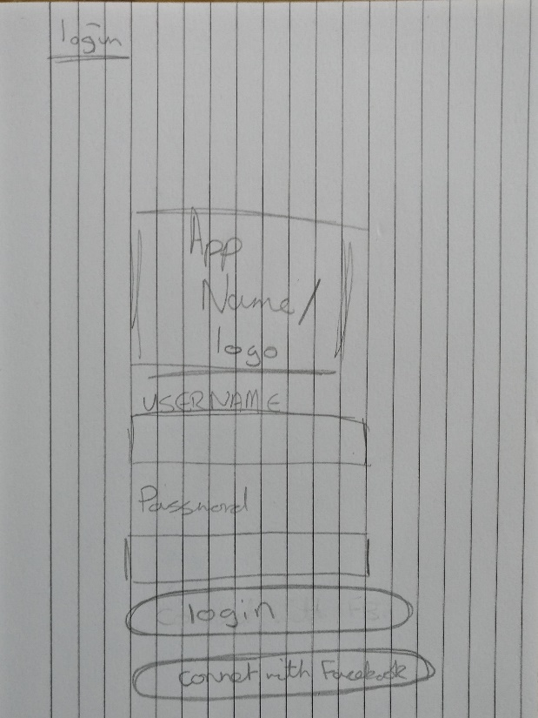

Additionally, but not as crucial to the above points, Lean UX was already familiar to the development team, the possesses and techniques involved in running a Lean UX project were already incorporated into the way the team conducted project development, which when considered alongside the other requirements of the project makes it a good fit as time spent developing skill with another project methodology could be better spent elsewhere.

Finally, despite the fact that Lean UX does not focus upon setting specific timeframes within a project, as a project should be considered finished when it meets its aims and objectives. This project must in the face of a real deadline be given a specific cut-off date. As such a Gantt chart was produced in order to maintain a good pace and stick to a timeframe that ensures project completion, as well as to allow the project team foresight when it comes to potential deadline clashes with other course related commitments. For reference to the Gantt chart please see **FIGURES 1 an d 2**  below;

## Gantt chart

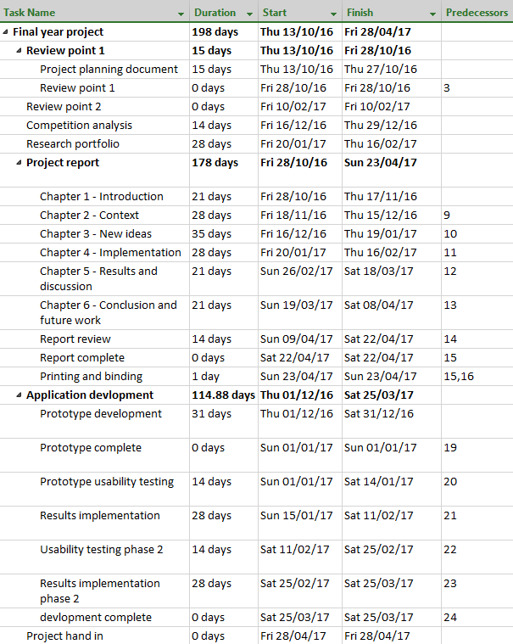

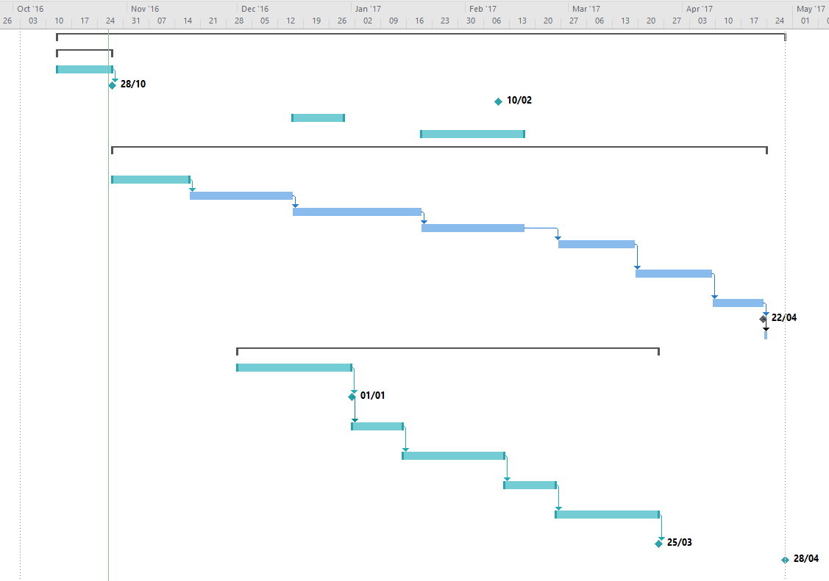

# Investigation

The following section outlines the investigation that took place to identify the selected genre, theme and style of the proposed application, this investigation entailed researching current popular mobile games and assessing their viability for this project. In total five games were researched to assess viability, these games were selected due to their top five position on the Top Games by All-Time Worldwide Downloads list (The Most Popular Google Play Apps of All Time, 2016). The selected games are as follows;

* Subway Surfers
* Candy Crush Saga
* Pou
* Temple Run 2
* Hill Climb Racing

Once a suitable list of games with which to investigate had been established it follows that some criteria for the investigation would need to be generated, the criteria and their reasoning within the investigation was as follows;

## Total downloads since release

Total downloads since release was selected as a criterion for the investigation as it provides evidence for what style and type of game is popular among users. This is a useful metric to track as designing an application which in some way attempts to take inspiration from what is currently popular has a greater chance of being itself successful.

## Popularity with user demographic

As the application discussed in this report was being targeted at a specific age group, it stood to reason to investigate the popularity the games in the investigation had with the target demographic, this allowed for a greater chance that the design created from this investigation would prove popular with the target demographic.

## Revenue generated

In preparation for potential future work related to the scientific questions briefly mentioned in the section above this metric has been added to this investigation as having the most solid foundation from which to work from will provide any future work in this project area the greatest chance of success.

## General review

A final criterion explored in this investigation was a general review of the game by the author, in summary this general review would cover; what was good and bad about the chosen game and whether the game be suitable for development in this project, i.e. could a similar game be produced by a single developer team.

## Conclusion

The investigation concluded that producing a game in the style of Candy Crush Saga would be the most suitable basis for the proposed application, this is due to the popularity of Candy Crush Saga among the target demographic, its high sale content for in game rewards, as well as the ease in which an application in its image can be created by a single member development team. Below find the investigation results for Candy Crush Saga, for all results from the investigation see appendix **Blah**.

## Candy Crush Saga results

**Google play release date:** November 2012

Figure 1

**Company:** Activision Blizzard

**Country of Headquarters:** United States

**Game link:** <https://play.google.com/store/apps/details?id=com.king.candycrushsaga&hl=en_GB>

**Total downloads since launch:** Over 500 million total downloads (Webster, 2017)

**Popularity among user demographic:** 40% total users fit user demographic profile (Newzoo, 2017)

**Revenue generated:** Dailyrevenue generation of an estimated $581,995 (Think Gaming, 2017)

**General review:** The game design of Candy Crush Saga is best described as a Match 3, this being a game of swiping various colours of object on screen to match three in a row, this will remove the matched items, granting the player points towards the score requirement of the level. It is easy to see where the popularity of Candy Crush comes from, the game is incredibly simple but well made, the simplicity of the game lends itself to ease of access from a variety of different users and the bright colours and consistent feedback from the game as well as a manageable difficulty curve will draw the player in. The game also operates on the concept of lives that recharge after a certain period of time has passed, this can leave the player yearning to return to the if they are unable to complete their current level with their remaining lives.

It should be noted that the 2D nature of this game lends itself to this project as it will require less time to fully implement a working solution when compared to a 3D game

# References

Terry, K. (2017). Number of Health Apps Soars, but Use Does Not Always Follow. [online] Medscape. Available at: http://www.medscape.com/viewarticle/851226 [Accessed 4 Dec. 2016].

The Most Popular Google Play Apps of All Time. (2016). [online] App Annie, pp.10-11. Available at: http://go.appannie.com/report-top-google-play-apps-all-time [Accessed 12 Jan. 2017].

Candy Crush saga – Android Apps on Google play (2016) Available at: https://play.google.com/store/apps/details?id=com.king.candycrushsaga&hl=en_GB (Accessed: 12 November 2016). (Candy Crush saga – Android Apps on Google play, 2016)

Webster, A. (2017). Half a billion people have installed 'Candy Crush Saga'. [online] The Verge. Available at: http://www.theverge.com/2013/11/15/5107794/candy-crush-saga-500-million-downloads [Accessed 24 Feb. 2017].

Fowler, M. and Highsmith, J. (2001). The Agile Manifesto. 1st ed.

Gothelf, J. and Seiden, J. (2013) Lean UX: Applying lean principles to improve user experience. Sebastopol, CA: O’Reilly Media.

Think Gaming. (2017a). Candy Crush Saga. [online] Available at: https://thinkgaming.com/app-sales-data/2/candy-crush-saga/ [Accessed 24 Feb. 2017].

Think Gaming. (2017b). Subway Surfers. [online] Available at: https://thinkgaming.com/app-sales-data/18/subway-surfers/ [Accessed 24 Feb. 2017].

Think Gaming. (2017c). Temple Run 2. [online] Available at: https://thinkgaming.com/app-sales-data/341/temple-run-2/ [Accessed 24 Feb. 2017].

Think Gaming. (2017d).Hill Climb Racing. [online] Available at: https://thinkgaming.com/app-sales-data/49/hill-climb-racing/ [Accessed 24 Feb. 2017].

Newzoo. (2017). *Supercell vs King: How do Clash of Clans and Candy Crush gamers compare? | Newzoo*. [online] Available at: https://newzoo.com/insights/articles/supercell-vs-king-how-do-their-gamers-compare/ [Accessed 24 Feb. 2017].

Subway Surfers *–* Android Apps on Google play. (2017). *Subway Surfers - Android Apps on Google play*. [online] Available at: https://play.google.com/store/apps/details?id=com.kiloo.subwaysurf&hl=en_GB [Accessed 24 Feb. 2017].

Pou – Android Apps on Google play. (2017). [online] Available at: https://play.google.com/store/apps/details?id=me.pou.app&hl=en_GB [Accessed 24 Feb. 2017].

Temple Run 2 – Android Apps on Google play. (2017). [online] Available at: https://play.google.com/store/apps/details?id=com.imangi.templerun2&hl=en_GB [Accessed 24 Feb. 2017].

Hill Climb Racing - Android Apps on Google play. (2017). [online] Available at: https://play.google.com/store/apps/details?id=com.fingersoft.hillclimb&hl=en_GB [Accessed 24 Feb. 2017].

# Appendix – Top 5 games

## Image result for candy crush saga icon iconCandy Crush Saga

**Google play release date:** November 2012

**Company:** Activision Blizzard

**Country of Headquarters:** United States

**Game link:** <https://play.google.com/store/apps/details?id=com.king.candycrushsaga&hl=en_GB>

**Total downloads since launch:** Over 500 million total downloads (Webster, 2017)

**Popularity among user demographic:** 40% total users fit user demographic profile (Newzoo, 2017)

**Revenue generated:** Dailyrevenue generation of an estimated $581,995 (Think Gaming, 2017a)

**General review:** The game design of Candy Crush Saga is best described as a Match 3, this being a game of swiping various colours of object on screen to match three in a row, this will remove the matched items, granting the player points towards the score requirement of the level. It is easy to see where the popularity of Candy Crush comes from, the game is incredibly simple but well made, the simplicity of the game lends itself to ease of access from a variety of different users and the bright colours and consistent feedback from the game as well as a manageable difficulty curve will draw the player in. The game also operates on the concept of lives that recharge after a certain period of time has passed, this can leave the player yearning to return to the if they are unable to complete their current level with their remaining lives.

It should be noted that the 2D nature of this game lends itself to this project as it will require less time to fully implement a working solution when compared to a 3D game

## Image result for subway surfersSubway Surfers

**Google play release date:** May 2012

**Company:** SYBO Games

**Country of Headquarters:** Denmark

**Game link** <https://play.google.com/store/apps/details?id=com.kiloo.subwaysurf&hl=en_GB>

**Total downloads since launch:** Between 500 million and 1 billion total downloads (Subway Surfers *–* Android Apps on Google play, 2017)

**Popularity among user demographic:** Statistic unavailable

**Revenue generated:** $15,628estimated daily revenue generation(Think Gaming, 2017b)

**General review:** Subway surfers falls into the game category of an endless runner, this being a game where the player character is constantly being propelled forward but must avoid obstacles within the game. The endless run category of game works well on a mobile device as the controls are intuitive in a phone with gyroscope enabled functionality such as being able to tilt the phone to make the player character move from side to side (Subway Surfers – Android Apps on Google play,2017).

## Image result for pou iconPou

**Google play release date:** August 2012

**Company:** Paul Salameh

**Country of Headquarters:** United States

**Game link:** <https://play.google.com/store/apps/details?id=me.pou.app&hl=en_GB>

**Total downloads since launch:** Between 500 million and 1 billion total downloads (Pou – Android Apps on Google play, 2017)

**Popularity among user demographic:** No accurate information available, however the art and design of the game is very simple, which appears to be targeted at younger children.

**Revenue generated:** No accurate information available

**General review:** A virtual pet simulator, in Pou the player must care for a virtual pet named after the games title, making sure to feed, clean and exercise the virtual character. The game feature of maintaining a character through user intervention raises the interesting possibility of creating a game based around a similar them, this is to say a virtual pet the player must look after through completing physical activity based tasks. However, as this wouldn’t constitute a more passive approach to user fitness and the fact the game appears to be targeted towards younger children, this style of game is not very suited to the requirements of this project (Pou – Android Apps on Google play, 2017).

## Image result for temple run 2Temple run 2

**Google play release date:** January 2013

**Company:** Imangi Studios

**Country of Headquarters:** United States

**Game link:** <https://play.google.com/store/apps/details?id=com.imangi.templerun2&hl=en_GB>

**Total downloads since launch:** Between 500 million and 1 billion total downloads (Temple Run 2 – Android Apps on Google play, 2017c)

**Popularity among user demographic:**

**Revenue generated:** $2,810 estimated daily revenue (Think Gaming, 2017)

**General review:** As with Subway Surfers above Temple Run 2 fits into the endless runner genre of games, the only real difference between the two is the aesthetic style, where Subway Surfers 2 uses a modern style, Temple Run 2 makes use of a more dated archaeological aesthetic. As with Subway Surfers, Temple Run 2 will not be selected as the game to base the style and theme of this project from this is due to the added development overhead of producing a 3D game (Temple Run 2 – Android Apps on Google play, 2017).

## Image result for hill climb racing iconHill Climb Racing

**Google play release date:** 2012

**Company:** Fingersoft

**Country of Headquarters:** United States

**Game link:** <https://play.google.com/store/apps/details?id=com.fingersoft.hillclimb&hl=en>

**Total downloads since launch:** Between 100 million and 500 million total downloads (Hill Climb Racing – Android Apps on Google play, 2017)

**Popularity among user demographic:** Information unavailable

**Revenue generated**: $1,308estimated daily revenue (Think Gaming, 2017d)

**General review:** Hill Climb Racing is a 2D physics based driving game based around the concept of the player having to drive a certain distance in each level without crashing the player characters’ car. The concept for the game is entertaining and could present an interesting subject for development, however, as information on the applications user base was unavailable the only reference point for the user base is to be found on the promotional video for the game which heavily features young children, if this group makes up the majority of the applications user base then it would be unsuitable for reaching the project aim of an application targeted towards older adults (Hill Climb Racing - Android Apps on Google play, 2017).